*Business proposal 2015*

DigiRAMP is seeking seed capital to reach first 30,000 beta users and 50,000 songs in 6 months.



Creators and owners of music need a better way to market their work and collect their fair share of revenues.

DigiRAMP provides control of rights, assets and revenue streams to the appropriate parties.

Artists and businesses now have the power to build an entire supply chain in a transactional market place: DigiRAMP.

Music consumers can now transact directly with the artists and rights owners, with transparency and direct, instantaneous accounting to all stakeholders.

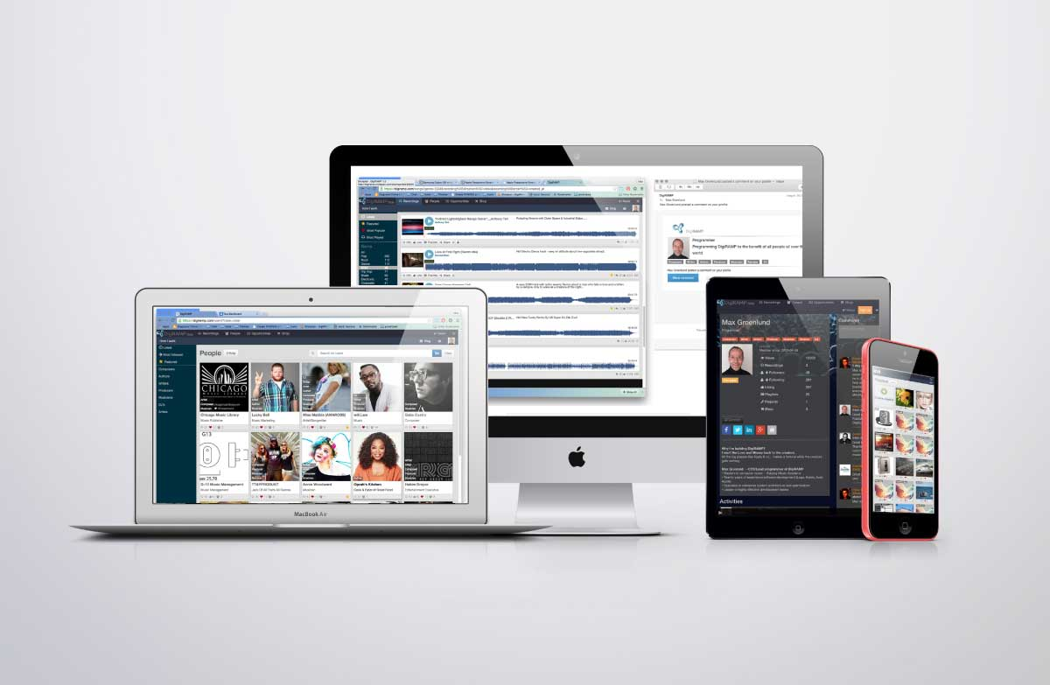

Table of content

DigiRAMP is founded by 8

Peter Rafelson 8

Max Grønlund 8

Why 8

Users 8

Features 8

The Channel 9

The Industry 9

Business model 10

Status 11

6 month goal 11

7-18 month goal 11

We offer 12

Budget 13

Production plan 14

Exit strategy 15

Technology Readiness 15

Protection readiness 15

Market readiness 15

References 16

# DigiRAMP is founded by

## Peter Rafelson

Veteran music businessman, composer, producer, musician and the creator of over thirty #1 songs, Peter has produced a massive catalog of 5,000+ masters

Peter owns five companies including publishing and record labels.

## Max Grønlund

Software architect, programmer, designer, IT Management:

Lego, Avid, Apple, Koblo, KeyToSound

Max invented the first Software “Virtual instruments” and Virtual DAW.

Max has also engaged with many of the most successful recoding artists as the CEO of Koblo

# Why

Today’s distribution channels provide close to no income to the creators of music.

Yesterday’s distribution channels are ineffective and expensive.

Writers and Artists are forced to accept big companies making big money from their music just so they may be distributed and heard.

# Users

Writers, Musician’s, Fans, Indie labels, Lawyers, Representatives and many more…

Can all fulfill their needs to connect and exchange value, services and products with respect to all rights holders and all receive revenue for their work and interests.

# Features

DigiRAMP is cloud-based solution where all users can:

Identify, listen to and license music.

Buy and sell products and services.

Upload recordings

Manage rights

Distribute revenue streams to all stakeholders

Collaborate

Connect and promote to social media

Professionals can subscribe to advanced features, which let them manage companies, employees and recording catalogs in bulk.

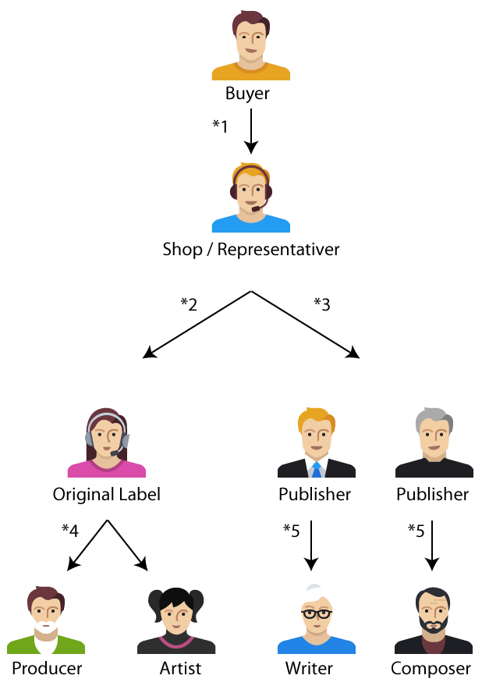

**Simplistic overview of revenue flow for mechanical usage of music**

1* When a mp3 file is downloaded a CD is sold or a song is streamed the shop receives the payment and take a rake often there is a payment fee

*2 The label receives it’s share according to the deal with the shop

*3 All publishers shares 9.1 cent for the mechanical royalty

*4 The people involved in the production of the master receives their share from the label

*5 The producers pays the creators of the song

Only the payment to the publishers is regulated by lav. The rest is based on agreements.

This example is only a part of how payments for usage of music are distributed. When it comes to licensing and public usage it works different

# The Channel

The traditional channel is slow. expensive and bureaucratic.

Many artists don’t know or simply don’t think it’s worth the effort to claim their rights.

The money is there but is hold in the first link of the chain. And only released when the income reach a threshold.

# The Industry

The business of Music is growing at an astronomical rate and has never seen so many people spend money on music as they do now. The annual growth has been 10% for the last year. Music is big business - just *not* for the creators.

But:

Creators get only 0.00019 cents per stream.

Apple only pays artists when a threshold of $100 is reached.

Popular artists such as Prince are receiving only a fraction of income for their catalogs on services such as Spotify, Pandora, etc…

SoundCloud is not paying writers for use of their work. On YouTube artists has to claim a share of the income from ads

It’s safe to say that most artists and writers rarely receive any compensation at all.

# Business model

DigiRAMP brings the control. Transparency and the income back the people that make the music.

DigiRAMP is not changing how the channel works on the contrary. DigiRAMP makes it easy to conduct business without violating anyone’s right.

The existing players are all invited to use DigiRAMP to conduct their business with all the benefits and cost reductions

Technology is used to automate processes and make it easy to create and administrate labels. Publishing. Licensing and build online shops

DigiRAMP takes a rake on all transactions - the rate varies from 1.9% to 20% depending on the amount of each transaction, the greater the transaction is the lower the cut.

The net result is that creators can get up to between 80 and 98% of the income if they manage the channel by them self.

DigiRAMP offers Pro Accounts at $19.95 a month and Business accounts at $159.00/mn.

# Status

DigiRAMP is currently in beta

1275 users

3,000+ recordings

5 Pro accounts

No significant burn rate

Lots of industry contacts

Backend can scale to 100.000 users with no slow-down

Unlimited storage & bandwidth

# 6 month goal

Grow the user base to 16k users and the content to 50,000+ recordings

Sell 320 Pro accounts

Develop account-streaming service and deploy shops for sale of products & services

Ramp up the staff with user support

Sign deals with independent labels/grow volume of recordings

Prepare technology for unlimited traffic and users

# 7-18 month goal

Grow users and content by 400%

Develop a pro streaming service (paid subscription model)

Make distribution and retail deals with additional, larger labels and catalogs

Create a DigiRAMP label, which can also aggregate rights and assets.

Improve user experience/workflow

Consolidate market position as a leader in rights and asset management

# We offer

100 Convertible Equity Certificates (A) for convertible stock sold in batches of 5, each note cost $ 2,500 so minimum is: $12,500

100 convertible equity certificates (B) for convertible stock sold for $3000, each.

A and B certificates will convert to 130% at A round

The convertible equity certificates will be offered on a monthly basis:

Starting:

Oct. 2015

3 (a) Certificates

10 (b) Certificates

For more information please contact

Peter Rafelson

peter@digiramp.com

# Budget

Sep 2015 - Feb 2016



# Production plan



# Exit strategy

If and when DigiRAMP has proven that it’s possible to conduct a fair and well-organized business big players will have no excuse for sending a fair share of the income to the creators.

That opens possibilities for DigiRAMP . At this point DigiRAMP might be for sale. This requires a level of readiness.

# Technology Readiness

Handling millions of micro transactions is not a trivial task. DigiRAMP has based it’s payment gate way on Stripe same payment gateway as Apple use. DigiRAMP will as it part of the readiness strategy migrate it’s backend from Ruby on Rails to Erlang. This improves performance cuts server costs and delivers cutting edge security and uptime. Erlang is used by Facebook. Snapchat and in the banking industry for safe transactions.

# Protection readiness

Workflows and the behind the scene automation processes will be subject to patens

# Market readiness

Having the majors and all the small independent labels and artists will give DigiRAMP an edge and the capability to jumpstart any major player

# References

<https://digiramp.com/>

<https://www.youtube.com/watch?v=lOCJL2M3IzM>

<https://www.youtube.com/watch?v=fY7_zPXcmNk>

[www.musicintofilm.com](http://www.musicintofilm.com)

<http://missmatildablog.com/qa-with-peter-rafelson-digiramp/>

<http://www.digitalmusicnews.com/2015/08/13/soundcloud-faces-massive-legal-action-before-thanksgiving-sources-say/>

<http://www.digitalmusicnews.com/2015/08/05/soundcloud-could-become-the-next-grooveshark-sources-say/>

<http://www.billboard.com/articles/business/6655915/how-the-blockchain-could-actually-change-the-music-industry>

<https://www.techdirt.com/blog/casestudies/articles/20130529/15560423243/massive-growth-independent-musicians-singers-over-past-decade.shtml>

<https://www.techdirt.com/articles/20150204/07310329906/yes-major-record-labels-are-keeping-nearly-all-money-they-get-spotify-rather-than-giving-it-to-artists.shtml>

<http://www.ifpi.org/consumer-research.php>